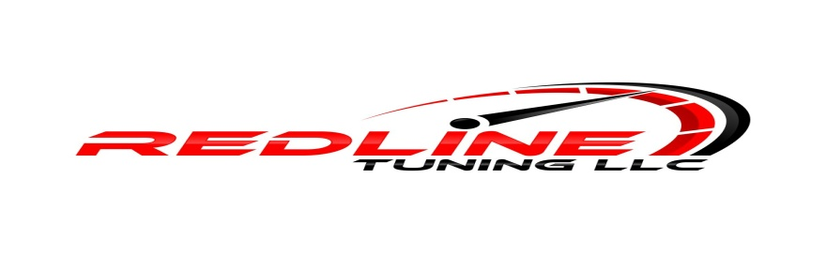
Vehicle Mod List
Year: ________________________________________________________________________________
Make: _______________________________________________________________________________
Model: ______________________________________________________________________________
Engine: ______________________________________________________________________________
Transmission: _________________________________________________________________________
Fuel Injectors(Brand And Size): ___________________________________________________________
Fuel Pump:____________________________________________________________________________
Fuel System Upgrades(Rails, Lines, Filters, etc.): ______________________________________________
Fuel Type(87, 93, E85, flex fuel, etc.): ______________________________________________________
Turbo: _______________________________________________________________________________
Intercooler Setup: ______________________________________________________________________
Boost Control: _________________________________________________________________________
Exhaust(Manifolds, Headers, Downpipe, Cat-back, etc.): _______________________________________
Other: ____________________________________________________________________________________________________________________________________________________________________________________________________________________________________________________________________________________________________________________________________________________
Current Issues/Concerns: _______________________________________________________________________________________________________________________________________________________________________________________________________________________________________________________________

